Experience sound like never before with the magic of Sennheiser
Sennheiser to launch Mirrorbox at Vivid Sydney for a collective audio experience
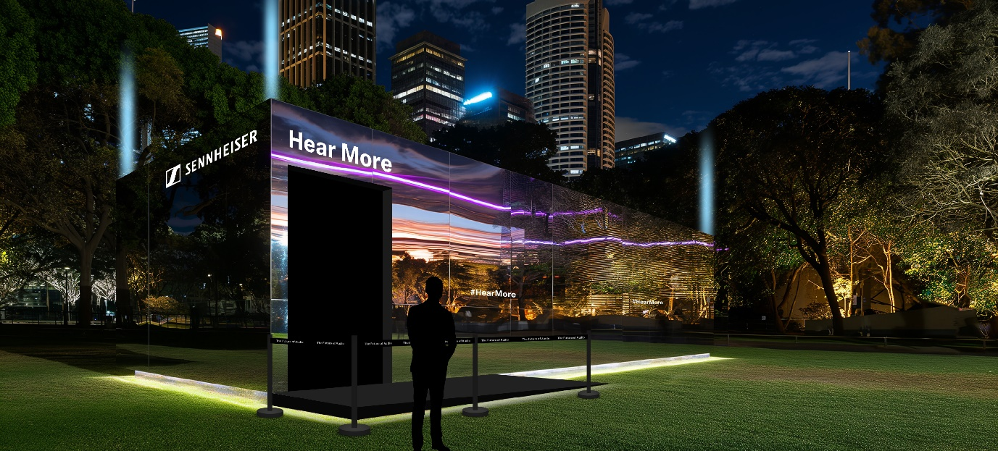

Sydney, Australia, 14 May 2024: As an official partner of Vivid Sydney 2024, the Sennheiser brand today announces the launch of its Mirrorbox which will be unveiled at the festival. The installation is an immersive AI audio experience that blends sound with emotion to create a musical journey for participants, reflecting the Vivid Sydney 2024 theme of ‘Humanity’.
Delivering magic at the centre of the audio-first experience is the world-class Sennheiser MOMENTUM 4 Wireless Headphones. The three-part journey starts with an AI analysis of your sound personality, mental mood, and biometric signature, which forms the foundation of your unique sonic fingerprint.
In the second stage, Sennheiser immerses you in an audioscape that blends the sounds of water with music composed to help you pause, reflect, and reconnect with the world around you.
FLOW is about the journey of water. But at its heart, it’s about the connection to humanity, nature, and the self. To aid your meditative journey, the experience incorporates a floor that reacts to the pulses and vibrations of the soundscape and draws your attention to a single illuminated structure in the centre of the room, which acts as a point of focus.
At the end of your FLOW journey, you’ll receive a personalised assessment and a playlist that captures your unique sonic identity.
Anne-Claire Costes – Sennheiser VP Marketing & PM says, “We are delighted to be an official partner of Vivid Sydney, where we will showcase how true sound can influence emotions. Our Mirrorbox will embody Hear More – through a dedicated space where visitors can reflect on the sounds that surround them.
"At Sennheiser, audio is more than just the output of engineering excellence. It’s key to raw, unfiltered emotional experiences. The feelings and meanings we associate with the sounds that surround us change depending on who we are. Our sound is a part of our story. When we Hear More, we learn more about what moves, shapes, and connects us.”
Anne-Claire continues, “Sennheiser has harnessed the power of our audio DNA as the Engineers of Magic to create not only an unforgettable cultural experience but an immersive moment with true sound where visitors can learn more about themselves and each other.”

Sennheiser’s Mirrorbox, situated in the beating heart of Vivid Sydney’s Light Walk, Tumbalong Park will be free for all visitors and open for the duration of Vivid Sydney. Vivid Sydney will be held from 24 May to 15 June 2024. For more information about the Vivid Sydney program and for tickets, visit vividsydney.com

Share your Sennheiser Mirrorbox experiences on social media with @sennheiser #Sennheiser #HearMore @vividsydney #VividSydney

ENDS

Press contact
humann. comms
Ellen O’Dwyer
+61 493 328 072
ellen.odwyer@humanncomms.com

About the Sennheiser brand
We live and breathe audio. We are driven by the passion to create audio solutions that make a difference. Building the future of audio and bringing remarkable sound experiences to our customers – this is what the Sennheiser brand has represented for more than 75 years. While professional audio solutions such as microphones, meeting solutions, streaming technologies, and monitoring systems are part of the business of Sennheiser electronic GmbH & Co. KG, the business with consumer devices such as headphones, soundbars and speech-enhanced hearables is operated by Sonova Holding AG under the license of Sennheiser.

www.sennheiser.com
www.sennheiser-hearing.com

About Vivid Sydney
Vivid Sydney, the Southern Hemisphere’s leading multi-artform festival, transforms Sydney into a vibrant hub of creativity,
innovation and community connection. Over 23 nights, light installations, music, ideas and food inspire global audiences
and drive cultural exchange. The 2024 theme, ‘Humanity,’ sparks reflection and engagement, attracting visitors and fuelling economic growth. Proudly owned by Destination NSW, Vivid Sydney showcases NSW’s cultural vibrancy and positions it as a global leader in artistic innovation.

